Under embargo. NOT for release before March 10, 2020- 8 am Central European Time

News Release
HP Disrupts Digital Printing with World’s Most Productive Press Portfolio
New 5th- and 6th- gen HP Indigo digital solutions engineered for fast growth opportunities

News highlights

- Series 5 and Series 6 are two new HP Indigo platforms delivering large digital print volumes thanks to high speed and productivity.
- Introducing the HP Indigo 100K B2-format commercial press, engineered for higher productivity with nonstop printing, delivering 6000 sheets per hour.
- Announcing LEP^{X}, HP Indigo’s speed-focused architecture, which runs as fast as analog.¹ The narrow-web HP Indigo V12 Digital Press for labels offers up to 12 colors on press, running at up to 120 meters per minute.
- Eight additional new presses slated for release in 2020: the B2 HP Indigo 15K, SRA3+ HP Indigo 7K and HP Indigo 7eco for commercial printing, as well as the HP Indigo 6K, HP Indigo 8K, HP Indigo 25K, for labels and packaging, and HP Indigo 35K and B1 HP Indigo 90K for folding carton and specialty applications.
- More than 100 parts in the drupa portfolio were produced with HP 3D printing with HP’s Multi Jet Fusion technology.
- HP PrintOS^{X} update unites cloud platform applications with an AI-driven service and support infrastructure offering solutions and automated processes as a cornerstone to the print factory of the future.
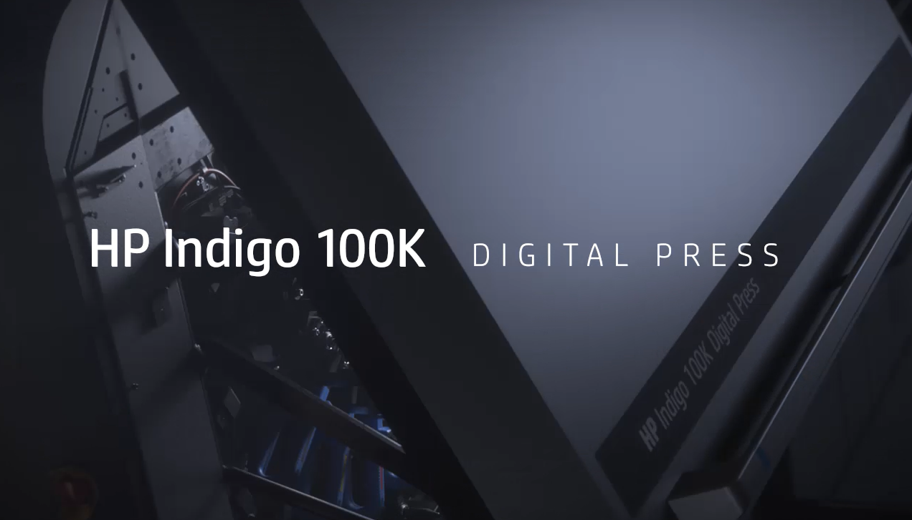
Watch the new HP Indigo 100K Digital Press video
PALO ALTO, Calif., March 10, 2020 — Ahead of drupa, HP Inc. (NYSE: HPQ) today announced two new bold and transformational HP Indigo generations designed for print service providers and converters to digitally print significantly higher volumes profitably. Thanks to innovations driving higher speed and productivity, both digital press platforms will unlock new opportunities for the analog-to-digital transformation.
- The new B2-format HP Indigo 100K Digital Press for commercial print, the first press in the new Series 5 platform, is engineered for higher productivity to deliver more than one million B2 duplex sheets per month. Printing at 6000 sheets per hour, the press is designed for offset players to adopt highly productive, on-demand printing with less waste. Commercial availability at drupa.
- For label production, the HP Indigo V12 Digital Press, designed with next-generation HP Indigo LEP^{X} architecture, is a narrow-web press that exploits the core power of Indigo’s Liquid Electrophotography (LEP) technology. First in the Series 6 platform, the HP Indigo V12 offers up to 12 colors on press, a speed of up to 120 meters per minute (400 f/pm), and multiplies productivity performance to match analog speed.¹ A new, automated color-matching technology, Spot Master, provides the industry’s fastest time-to-color.²
The drupa portfolio also delivers continued innovation in eight additional new presses: the B2 HP Indigo 15K, SRA3+ HP Indigo 7K and HP Indigo 7eco for commercial printing, the HP Indigo 6K, HP Indigo 8K, HP Indigo 25K for labels and packaging, and the HP Indigo 35K and B1 HP Indigo 90K for folding carton and specialty applications. Value packs with upgrade options will allow existing customers to benefit from these new features and capabilities.
“The need for high-quality, versatility and productive digital printing is crucial today, given the rising demand for same-day delivery, sustainability and customized print experiences. With the new portfolio, we’ve set the stage for our customers to grow and build the print factories of the future. In today's fast-paced environment, where jobs can suddenly land on your doorstep, customers need the agility to react quickly so they can profitably cash in on those opportunities,” said Santi Morera, general manager and global head of graphics solutions, HP Inc.
“Over the last four years, HP customers have almost doubled business, generating $15 billion in revenue in the last year alone from over 100 million print orders.³ We believe the dramatic innovations in our drupa portfolio will usher in a new era that will drive continued growth for customers over the next decade and beyond,” said Alon Bar-Shany, general manager, HP Indigo.
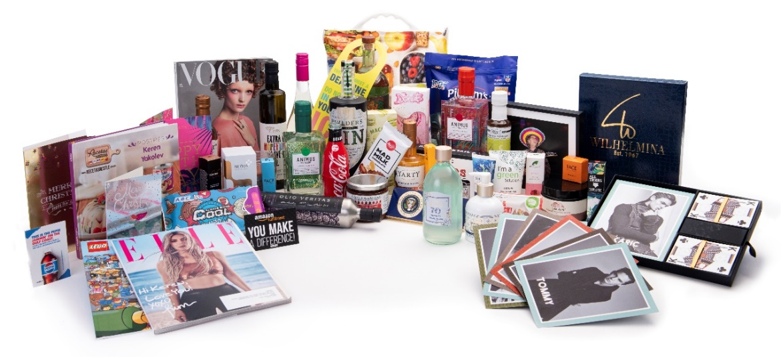
HP Indigo's wide portfolio of digital presses is making an impact across print.
New HP Indigo 100K commercial press creates more profit opportunities
The world’s most productive digital B2 solution,⁴ the HP Indigo 100K Digital Press is designed for high productivity required by offset players to transition more work to digital and boost sustainability with on-demand printing.
Engineered for nonstop printing, the new HP Indigo 100K is Indigo’s first Series 5 press and delivers significantly higher productivity with Indigo’s renowned digital offset look and feel. Delivering 6000 sheets per hour⁵, the HP Indigo 100K four-color press boosts margins on short-run digital production and introduces new calculations that confirm a lower total cost of ownership. The HP Indigo 100K uses advanced paper handling and offset-like gripper-to-gripper design for precision registration, and also enjoys boosted digital capabilities including a five-input source feeder, color automation, calibration and fast switchover between jobs and media.
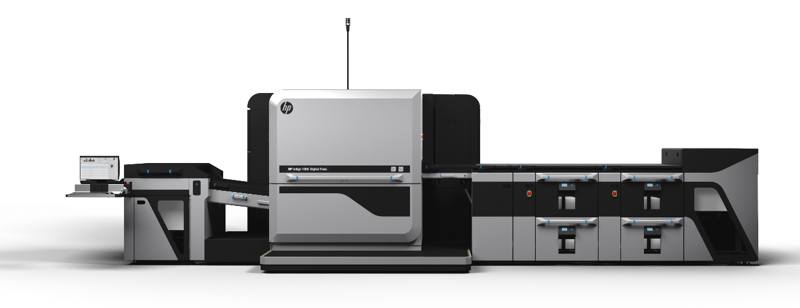
The new HP Indigo 100K Digital Press, engineered for high digital productivity.
Customer beta testing, launched before 2019 peak season, is now concluding at commercial PSPs globally, including offset players. The HP Indigo 100K is scheduled for commercial release at drupa.
Since its drupa 2012 debut, the HP Indigo B2 format digital sheetfed is the market leader with more than 1000 units sold.⁶
New LEP^{X} architecture unleashes the power of HP Indigo
LEP^{X} releases the core physics of LEP technology, producing Indigo’s renowned, high-quality digital printing. In LEP^{X} architecture, six imaging engines operate inline simultaneously, instead of LEP’s single engine, multiplying speed to match analog with the added benefits of digital printing. As a result, LEP^{X} offers the speed and efficiency for PSPs to profitably produce large print volumes than previously possible.
Highlights of the LEP^{X}:
- Operators can run jobs at a single predictable speed, regardless of the type of graphics, ink coverage or specialty colors.
- Up to 12-colors on press. Change inks on the fly and create any color combination.
- Crisp 1600 dpi native print resolution.
- The HP Indigo V12 narrow-web press prints at 120 linear meters/min (400 fpm) for any job with up to 6 colors, comparable to analog speed. The press also supports the digital label industry’s largest range of substrates, from 12 microns unsupported film to 450-micron (18 pt) board, using the integrated inline primer.
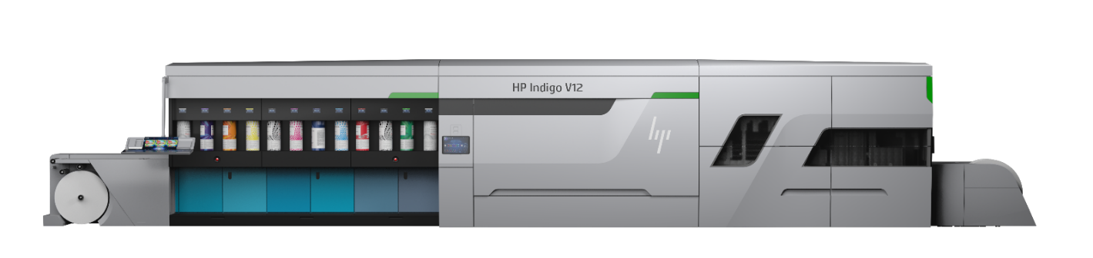
The HP Indigo V12 Digital Press is built on next-generation LEP^{X} architecture.

HP 3D printing production opens a new era of digital manufacturing
More than 100 parts in the new HP Indigo drupa portfolio of presses were produced using HP’s Multi Jet Fusion technology, including on the HP Indigo 100K Digital Press, HP Indigo V12 Digital Press, and HP Indigo 15K Digital Press.
HP 3D printing technology enables HP to accelerate learning and design cycles, delivering parts in days versus weeks, reducing carbon footprint⁷ by decreasing energy and material consumption, with some parts up to 90% lighter.⁸
One platform for automation and excellence
Beyond the press, HP PrintOS^{X} unites cloud-platform applications with an AI-driven service and support infrastructure to enable customers to get the most out of their press investment. Based on PrintOS^{X} advanced technology, tools and know-how, customers can start building the “print factory of the future” and reach operational excellence, automate production, and innovate with high-value applications.
Launched at drupa 2016, more than 12,000 HP customers are now connected on HP PrintOS, using a range of applications that leverage big data on the cloud in real time for all types of production challenges. Applications helping drive success for PSPs include:
- Marketplace, now featuring a new UI, is loaded with new applications and partner solutions, including information on the latest market trends and business opportunities, as well as hundreds of free open artwork files that customers can customize for their needs.
- Mosaic now made easier. In collaboration with Microsoft Xiaoice, unlimited unique “mosaic-ready’ seed patterns created by AI technology are available in Marketplace. Enabling designers to create unique hyper-customization projects faster and more cost effectively, the first 4000 mosaic patterns are available free of charge until the end of 2020.
- HP Site Flow is an end-to-end production automation solution from ordering to shipping. Site Flow offers now three user levels – Lite, Pro and Enterprise – supporting PSPs producing as few as 50 jobs per day to over 10,000. In 2019, more than 20 million print orders were processed by Site Flow, a 34% increase year-over-year.
- Color Beat now enables automated G7 color certification via HP Indigo press connectivity.
- Predictive Press Care algorithms proactively address potential press issues before they impact production.

Availability
The B2 HP Indigo 100K and HP Indigo 15K, SRA3+ HP Indigo 7K and HP Indigo 7eco for commercial, as well as the HP Indigo 6K, HP Indigo 8K, HP Indigo 25K, HP Indigo 35K, and HP Indigo 90K for labels and packaging are all scheduled to be available in June or later in 2020.
The HP Indigo V12 Digital Press will be demonstrated at drupa. The press is scheduled for commercial availability in 2022.
Visit the HP drupa online press kit for more information on today’s announcements and to follow HP’s drupa news.
About HP Inc.
HP Inc. (NYSE: HPQ) creates technology that makes life better for everyone, everywhere. Through our product and service portfolio of personal systems, printers and 3D printing solutions, we engineer experiences that amaze. More information about HP Inc. is available at www.hp.com.

- Compared to printing competitors providing narrow-web solutions as of March 10, 2020.
- According to HP Internal analysis of print solutions as well as customer validations.
- According to HP internal data.
- Compared to printing competitors providing B2 solutions, as of March 10, 2020.
- 6000 sheets per hour, printed in EPM (3-color Enhanced Productivity Mode).
- Based on HP internal data.
- Carbon footprint reduction based on HP comparative analysis between CNC machined parts and 3D printed plastic parts. The analysis shows that there is a benefit to be gained in switching the original metal fixture for a 3D printed design. Depending on the design iteration and material, the carbon footprint reduction can be between 44% to 83%.
- Weight reduction calculated based on: Aluminium machined part: 10kg, MJF part: 0.8 kg.

Vanessa Forbes, HP  vanessa.forbes@hp.com  www.hp.com/go/newsroom | Nina Gilbert, HP  nina@hp.com

